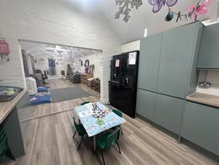

 |  | Southery Playgroup | February 2025
 |  | The latest at your child’s Playgroup.
INSIDE  Please see the new improvements we have had ready for Wraparound care in April.  Hours  Morning: 8:55am – 11:55am  Afternoon: 12.10pm – 3.10pm  All day: 8.55am – 2.55pm  Early and late times  8:45am-3:10pm - £5 daily charge  8:45am-2:55pm - £3 daily charge  8:45am-11:55am - £3 daily charge  Key dates  Feb Half Term: 17th to 21st  Easter Half Term: 7th to 22nd April  May Bank Holiday: 5th May  May Half Term: 26th to 30th May  Summer Break: 23rd July to 2nd September |  | 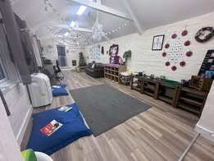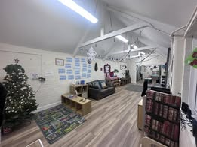  We hope you all had a lovely Christmas.  Thank you so much for your continued support with our Wish Tree, the children are enjoying the wide variety of snacks. If you can think of anything different that the children may like, please bring it in for them to try. Also, any surplus items you think will be of use to us will be appreciated. With this in place, if it is a success, then we will not be charging for consumables like other settings.  Just a few reminders:  • Please NAME your children’s items such as coats, bags and lunchboxes  • Please keep us updated on any changes to your child’s details, address, phone numbers, authorised people to collect etc.  • Ensure your children have appropriate clothing for the weather conditions as we spend time outdoors whatever the weather.  • Keep an eye on updates via Class Dojo and our Facebook page.  • At collection/drop off time please can you keep an eye on your children, they are your responsibility until they enter and when they leave playgroup.  WrapAround  From 23rd April we will be open from 8:00 am to 8:55am for Breakfast Club. Then afterschool club until 5:30pm. We close 3:10pm on Fridays. This is open to anyone 2 years to 7 years. There will be a charge. This will need to be booked and paid for in advance.  Breakfast club: £6.00 this will include breakfast  Afterschool club: £15 this will include dinner  Please talk to Kerry for more details.  Fundraising  Friday 28th March – Easter bingo @ Southery Village Hall. Doors open 7pm eyes down 7:30pm.  Thursday 20th November – Our Annual Christmas shopping night @ Southery Village Hall. 6 to 8pm.

